King Fahd University of Petroleum & Minerals
COE 292: Introduction to Artificial Intelligence
Dataset Report

Project Name: | Air Quality Classification
Group Number: | ZK-3
Date: | 12/04/25
Number of student in the group: | 4

Student 1:
Name | Yousef Alhadlaq
KFUPM ID | 202274280
Department | ICS department

Student 2:
Name | Mohamed Hefnawy
KFUPM ID | 202259240
Department | Electrical Engineering

Student 3:
Name | Mohammed Alsuhaibani
KFUPM ID | 202245800
Department | ICS department

Student 4:
Name | Saad AlMuqati
KFUPM ID | 202169310
Department | Industrial and Systems Engineering Department

Summary of Classification problem
Air pollution has a significant impact on public health, making the classification of air quality essential for monitoring and regulatory actions. This dataset is designed to classify air quality into four categories: Good, Moderate, Poor, and Hazardous. The dataset consists of multiple environmental features, including PM2.5, PM10, NO2, SO2, CO, temperature, humidity, proximity to industrial areas, and population density. These features are highly variable and interdependent, making classification difficult. The challenge arises from the nonlinear relationships between pollutants and their impact on air quality. This classification is crucial in environmental studies, urban planning, and public health, allowing authorities to take timely actions.

Source:
website of the dataset: https://www.kaggle.com/datasets/mujtabamatin/air-quality-and-pollution-assessment

Statistics

No. | Question | Student Response
1. | How many labeled examples are in your data set? | 4740
2. | How many distinct features are in your data set? | 9
3. | How many distinct labels (classes) are in your data set? | 4
4. | For each label, what is the percentage of data? | Good (35%), Moderate (25%), Poor (20%), Hazardous (20%)
5. | Is the dataset balanced based on the above? | [ ✔] Yes [ ] No  If No then explain why:
6. | Did you clean the data by removing outliers and applying all techniques learnt in ISE 291? | [ ✔] Yes [ ] No  If No then explain why:

Feature (variable) explanation
No. | Feature used in file | Short Feature explanation/description
1. | Temperature | Measures ambient air temperature in Celsius.
2. | Humidity | Represents the amount of moisture in the air.
3. | PM2.5 | Particulate matter smaller than 2.5 micrometers, a key air pollutant.
4. | PM10 | Particulate matter smaller than 10 micrometers, another pollution indicator.
5. | NO2 | Nitrogen dioxide, a common air pollutant from vehicles and industry.
6. | SO2 | Sulfur dioxide, mainly from industrial emissions.
7. | CO | Carbon monoxide, a toxic gas from combustion.
8. | Proximity to Industrial Areas | Distance of observation from industrial zones.
9. | Population Density | Number of people per square kilometer, affecting pollution levels.

Label explanation

No. | Feature used in file | Short Feature explanation/description
1. | Good | Air quality is clean and poses little to no health risks.
2. | Moderate | Air quality is acceptable but may cause issues for sensitive individuals.
3. | Poor | Air quality is unhealthy, with possible effects on the general public.
4 | Hazardous | Air quality poses serious health risks and requires immediate attention.

Data visualization

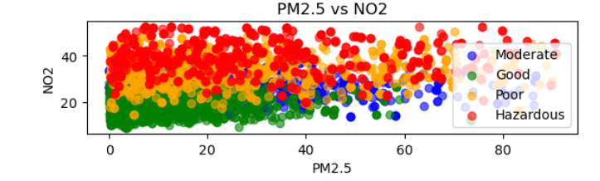  Figure 1 | 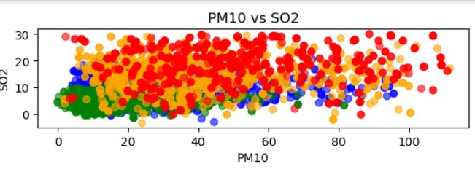  Figure 2
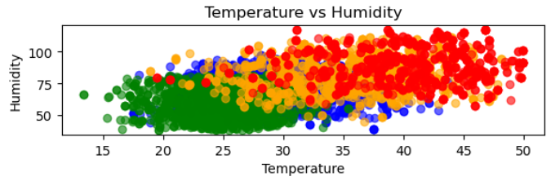  Figure 3 | 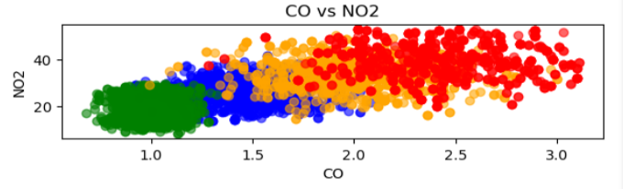  Figure 4
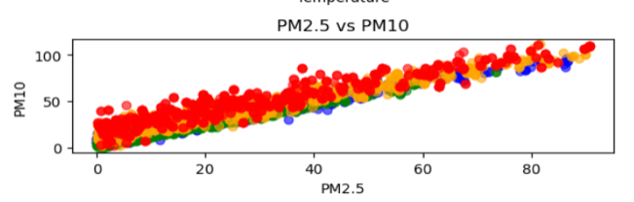  Figure 5 | 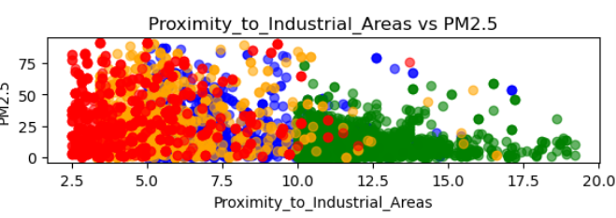  Figure 6
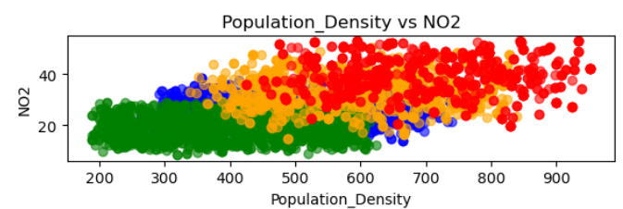  Figure 7 | 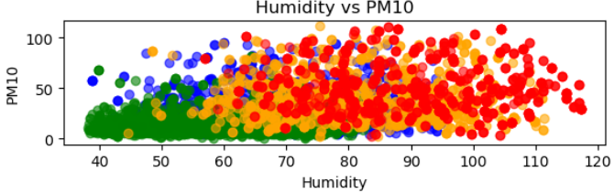  Figure 8

Conclusion
Air quality classification is crucial for monitoring pollution and ensuring public health. By developing a machine learning model to classify air quality, authorities can issue timely warnings and enforce environmental regulations. This classifier helps predict pollution trends, optimize urban planning, and improve air quality management strategies. The complex interactions between pollutants require advanced models, making this classification an essential component of artificial intelligence applications in environmental science.

K-NN Algorithm
Dataset Preparation and Feature Scaling
The Euclidean distance serves as the default distance metric for the K-NN algorithm implemented through the KNeighborsClassifier. This distance is computed using the formula:
$$Euclidean distance= \sqrt{{(x_{2}-x_{1})}^{2}+(y_{2}-y_{1})^{2}}$$

However, the dataset comprises features with significantly differing ranges, such as temperature varying from approximately 13 to 58, PM2.5 levels reaching up to 295, and CO concentrations ranging from 0.65 to 3.72. Utilizing Euclidean distance without preprocessing would lead to features with larger values dominating the distance calculation. This dominance could introduce bias into the model, skewing its performance and reducing overall effectiveness.

To address this issue, the application of StandardScaler for feature scaling is appropriate. This method transforms all features to possess a mean of 0 and a standard deviation of 1. Such standardization ensures that each feature contributes equally to the distance metric, irrespective of its original scale. Consequently, no single feature disproportionately influences the outcome, thereby rendering the distance calculations fair and reliable. The following KDE plots generated before and after scaling effectively demonstrate the standardization of data distribution.
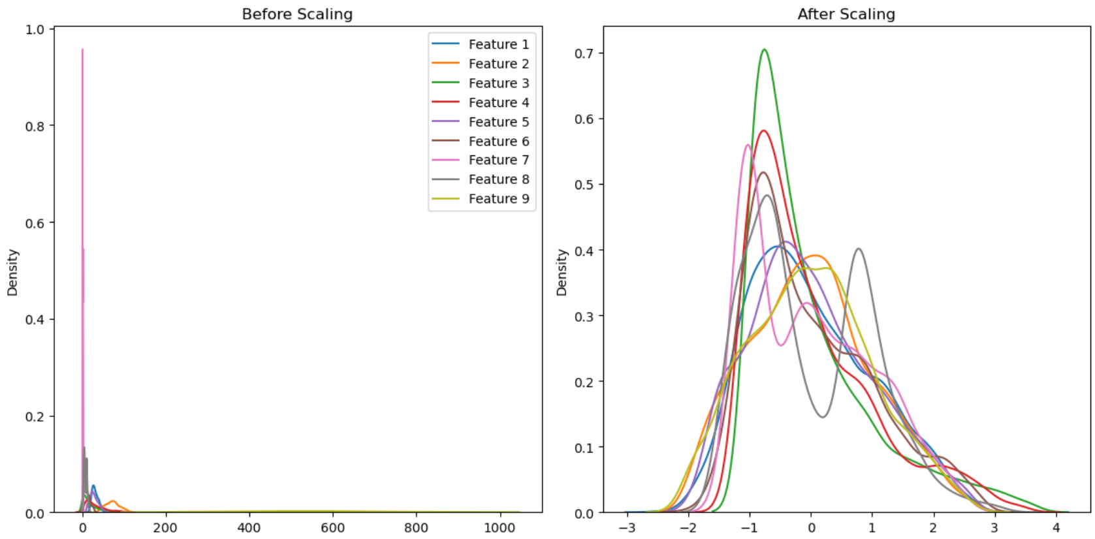

Choosing the Right Value of K
The influence of the number of neighbors on the classification performance of the model was studied systematically with the K value ranging from 1 to 24. This was done by training the model on every value of K for the scaled training data and then evaluating its error rate on the scaled test set. The result was saved and graphed in the following plot.
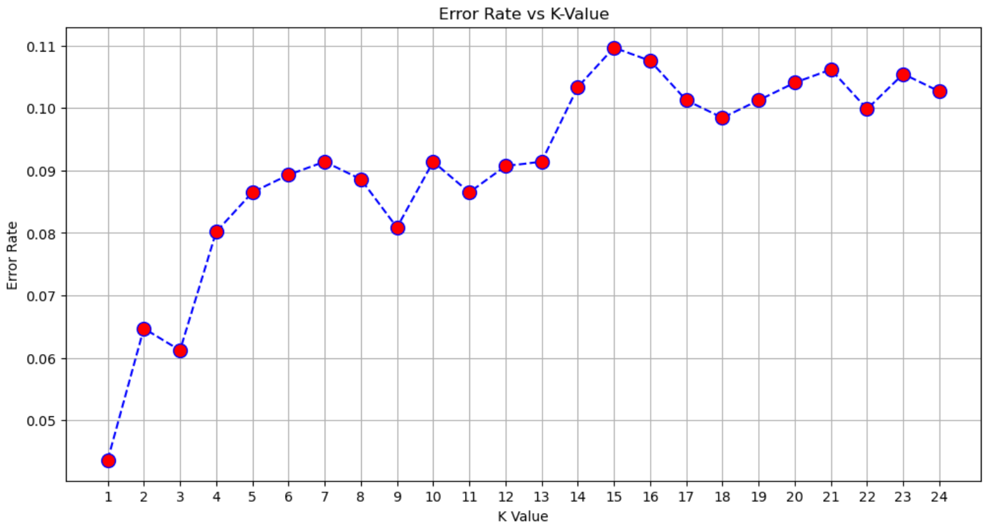
This plot demonstrates how the error rate changes with changing values of K. The lowest error rate of 4.36% was observed when K = 1. While increasing K, the error rate slowly increased up to approximately 11% for K = 15.

Model Performance

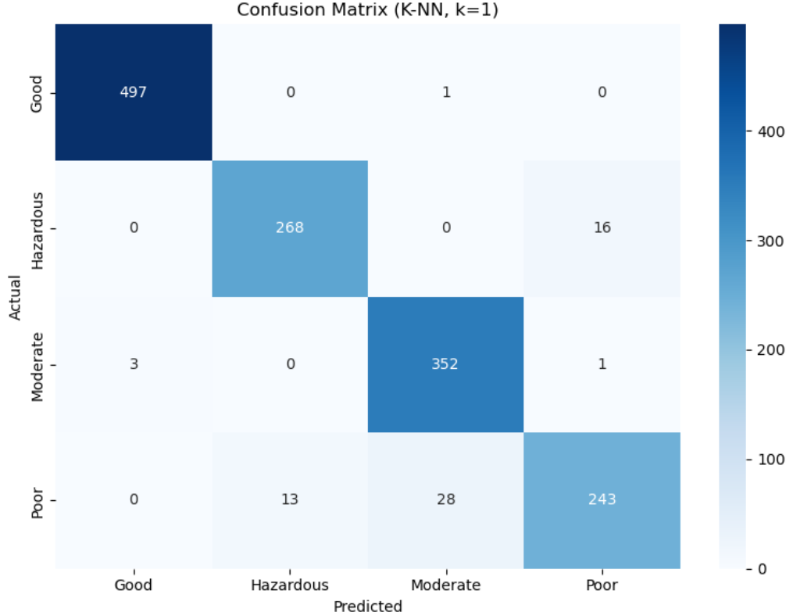
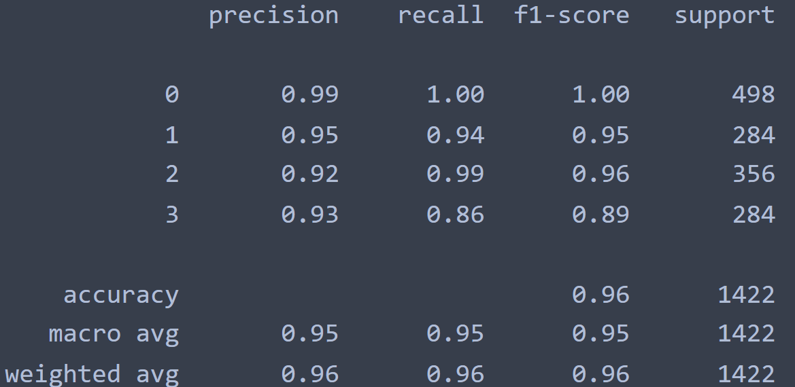
Based on the confusion matrix and classification report for the K-NN model with k=1, the model demonstrates robust overall performance across all classes, achieving an accuracy of 96%. The true positive rates are notably high for the "Good" and "Moderate" categories, with true positive rates of 34.96% and 24.76%, respectively. The false positive and false negative rates are relatively low across all classes, indicating that the model makes few incorrect predictions.
For example, the "Hazardous", "Moderate" and ‘Poor’ classes have false negative rate of only 1.13%, 2.04%, and 2.88% respectively which are quite acceptable.

Cross-Validation
To ensure that the KNN model performs satisfactorily and does not overfit to the training data, 5-fold cross validation was used on the whole scaled data set. The technique provides a balanced solution to estimating performance through controlling bias and variance. In contrast to a single train test split, whose result is very data split dependent, k-fold cross validation minimizes variability by training and testing on each data point. Utilizing 5 folds maintains training performance while providing a good model generalizability estimate. The model is trained in 4 folds and evaluated on the remaining one, repeating this process 5 times such that every fold is employed as a test set once.

The cross-validation accuracy scores across the five folds were 0.9557, 0.9578, 0.9589, 0.9631, and 0.9599, all of which were uniformly high, reflective of the model performing consistently across various subsets of data. The average accuracy of 95.91% again confirms that the KNN model with K=1 possesses good generalizability and retains strong predictive capability without overfitting or underfitting. The consistency in this performance by the folds reflects the strength of the model and highlights the effectiveness of using k-fold as a cross-validation technique.

SVM Algorithm
Dataset Preparation and Feature Scaling
Before training the Support Vector Machine (SVM) model, data preparation was essential to ensure optimal performance. The dataset contained features such as Temperature, Humidity, PM2.5, PM10, NO2, SO2, CO, Proximity_to_Industrial_Areas, and Population_Density, which vary widely in scale and units. To prevent features with larger numerical ranges (like PM10 or Population Density) from dominating the SVM's decision-making, we applied MinMaxScaler from sklearn.preprocessing to scale all features to a range between 0 and 1. This step is crucial in SVM since it is sensitive to feature magnitudes when calculating distances and finding the optimal hyperplane. Feature scaling ensures that all variables contribute equally to the model, thereby improving classification accuracy and training efficiency

Support vectors
Support vectors are the critical data points that lie closest to the decision boundary (also called the hyperplane). In SVM, only these points influence the orientation and position of the boundary; all other data points have no direct impact on it. These vectors are essentially the most difficult points to classify correctly.
In a hard margin SVM, the model tries to find a decision boundary that perfectly separates classes without allowing any misclassifications. This only works when the data is linearly separable. However, our dataset contains overlapping features (e.g., similar humidity or PM2.5 levels across different air quality classes), making perfect separation impractical. Therefore, we used a soft margin SVM, which introduces a penalty term to allow some misclassification in exchange for a wider margin and better generalization. This flexibility ensures that the model does not overfit noisy or outlier data.
In both margin types, the support vectors are the data points that lie within or on the margin boundaries. The margin is maximized by optimizing the distance between the hyperplane and the nearest support vectors from each class. A wider margin results in better generalization and more robust predictions on unseen air quality data.
Kernel Functions
The relationship between air quality and its features is not strictly linear. For instance, the combination of high PM2.5 and CO might indicate poor air quality even if the temperature is moderate, introducing non-linear relationships in the data. To capture this complexity, we experimented with different kernel functions using the SVM classifier.
We tested the linear kernel as a baseline but observed limited performance. Then, we used the Radial Basis Function (RBF) kernel (Gaussian kernel), which used to make non-linear decision boundaries controls how far the influence of a single training example reaches. The RBF kernel maps the input data into a higher-dimensional space, allowing the model to construct a more flexible decision boundary. Through trial and error and cross-validation, we found that the RBF kernel captured the non-linear patterns of the dataset effectively, producing better classification results.
Model Performance
To evaluate the performance of the SVM model, we used a confusion matrix, which compares the predicted and actual air quality classes:
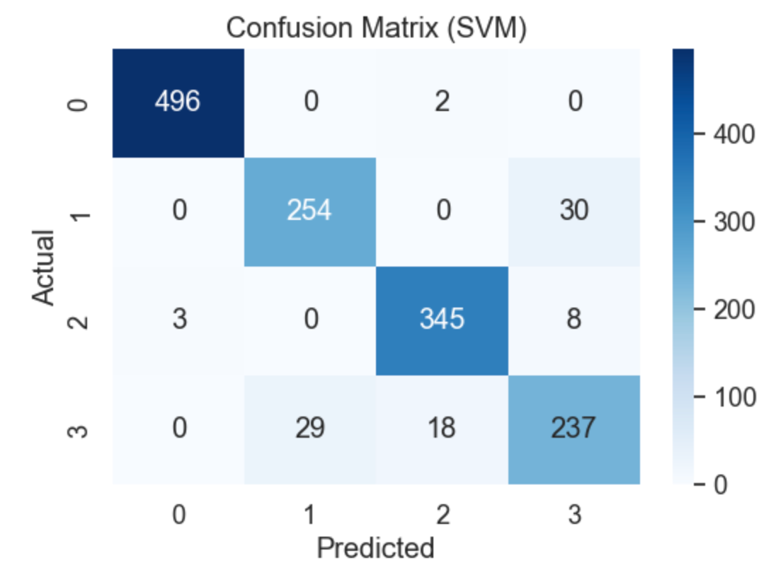

The matrix shows that the model correctly classified 496 instances of class 0, 254 of class 1, 345 of class 2, and 237 of class 3. However, there were misclassifications such as 30 samples from class 1 being predicted as class 3, and 29 class 3 samples being predicted as class 1, indicating some overlap in feature patterns between these two classes.

The overall accuracy of the model is 94%, which indicates a high performance. From the classification report:
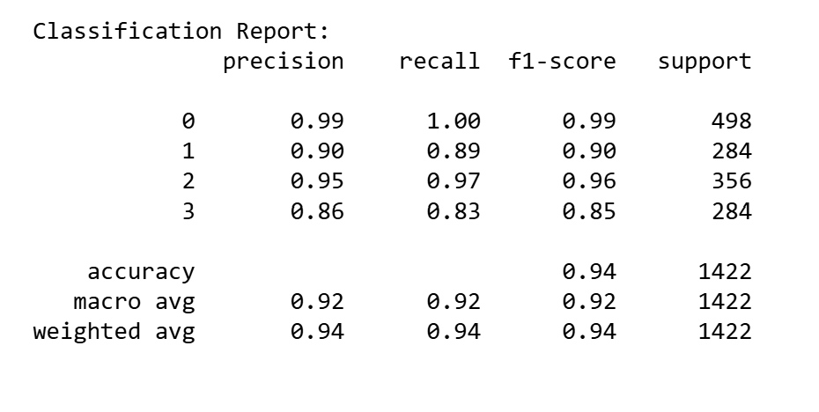
- Precision ranged from 0.86 to 0.99, showing the model was reliable in predicting most classes correctly when it made a prediction.
- Recall ranged from 0.83 to 1.00, indicating that the model was able to identify the majority of actual class instances, especially for class 0.

Cross-Validation

In our implementation, we used 5-fold cross-validation to validate the performance of the SVM model. This technique involves splitting the training dataset into five equal subsets (folds), where in each iteration, four folds are used for training and one for validation. The process is repeated five times, ensuring every instance is used for both training and validation exactly once.

We specifically chose 5 folds because our dataset, after cleaning and preprocessing, consists of a moderate sample size that balances between computational efficiency and statistical reliability. Using 5-fold cross-validation allows us to get a reliable estimate of model performance without excessive computational cost.

This approach ensures that the model is not overfitting to any subset of the training data and provides a more robust evaluation of its ability to generalize to unseen data. The averaged accuracy across folds gives a stable measure of performance, making 5-fold a practical and effective choice.

Deep Learning/CNN Algorithm
Dataset Preparation and Feature Scaling
To ensure that no single feature disproportionately affects the training process we do the Standard Scaler and its job to have a mean of 0 and standard deviation of 1, ensuring a balanced influence of each feature on the gradient descent optimization. Lager magnitudes slower the process and make one feature dominate the loss gradient
Network Architecture Design
The architecture used in the code is a fully connected feedforward neural network and the layers are as follows:
- Input Layer: Accepts input features with a shape equal to the number of features in X
- Hidden Layers: Two hidden ones are the first has 64 neurons, and the second has 32 neurons, both using the 'relu' activation function. These sizes offer a balance between learning capacity and avoiding overfitting.
- Output Layer: A Dense layer with num_classes neurons and 'softmax' activation is used for multiclass classification.
The depth (number of layers) allows the model to learn complex hierarchical features, while the width (number of neurons) provides sufficient capacity to capture patterns in the data.
Activation Functions
We use 'relu' activation function in the hidden layers, chosen for its simplicity and effectiveness in mitigating the vanishing gradient problem, which often occurs with sigmoid or tanh. 'relu' allows for faster training and better convergence by only activating neurons with positive inputs. The output layer uses 'softmax', which is standard for multiclass classification as it converts logits into probability distributions over classes. We use a batch size of 32, which provides a good balance between stability and speed of training.
Hyperparameter Tuning
the Adam optimizer is used, which includes an adaptive learning rate mechanism. While the default learning rate in Adam is typically effective, tuning it manually can help refine the convergence behavior. A too-high learning rate may cause the model to overshoot minima and fail to converge, while a too-low rate slows training and may get stuck in suboptimal local minima. While the current model uses the default rate.

Model Performance
The Accuracy and precision and recall for each fold is:
--- Fold 1 ---
Accuracy: 0.93
Precision: 0.93
Recall: 0.93
--- Fold 2 ---
Accuracy: 0.93
Precision: 0.93
Recall: 0.93
--- Fold 3 ---
Accuracy: 0.91
Precision: 0.91
Recall: 0.91
--- Fold 4 ---
Accuracy: 0.92
Precision: 0.92
Recall: 0.92
--- Fold 5 ---
Accuracy: 0.92
Precision: 0.92
Recall: 0.92
And by taking the average the summary is
Average Accuracy: 0.9224
Average Precision: 0.9228
Average Recall: 0.9224
And by looking into these numbers we found that it is shuffled correctly because the numbers are near each other. Additionally, as there is no need to have high precision or recall as the our task requires the accuracy of our module has no different from them in each fold
Cross-Validation
K-Fold Cross-Validation ensures that the model is evaluated on different subsets of the data and reduces the risk of overfitting to a particular train/test split. Each fold trains and validates the model independently, and performance is averaged, providing a more robust evaluation

Comparison between KNN, SVM and deep NN/CNN.
The three classification techniques—K-NN, SVM, and DNN—performed well on the air quality dataset, each with its own strengths. K-NN achieved the highest accuracy at 96%, making it the best overall for this specific problem. SVM followed with 94% accuracy and handled overlapping class features effectively using the RBF kernel. The DNN reached an average accuracy of 92.24%, showing consistent results across all folds and strong generalization.
K-NN is better suited for simple problems and smaller datasets. SVM performs well when class boundaries are not clearly defined. The DNN, while slightly lower in accuracy here, is powerful for learning complex patterns, especially with more data. The performance differences come from how each model works: K-NN relies on distances, SVM uses support vectors and margins, and DNNs learn from multiple layers of weights and activations.
DNN
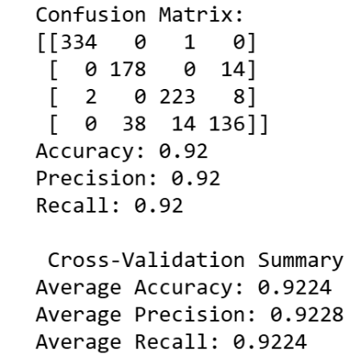

SVM

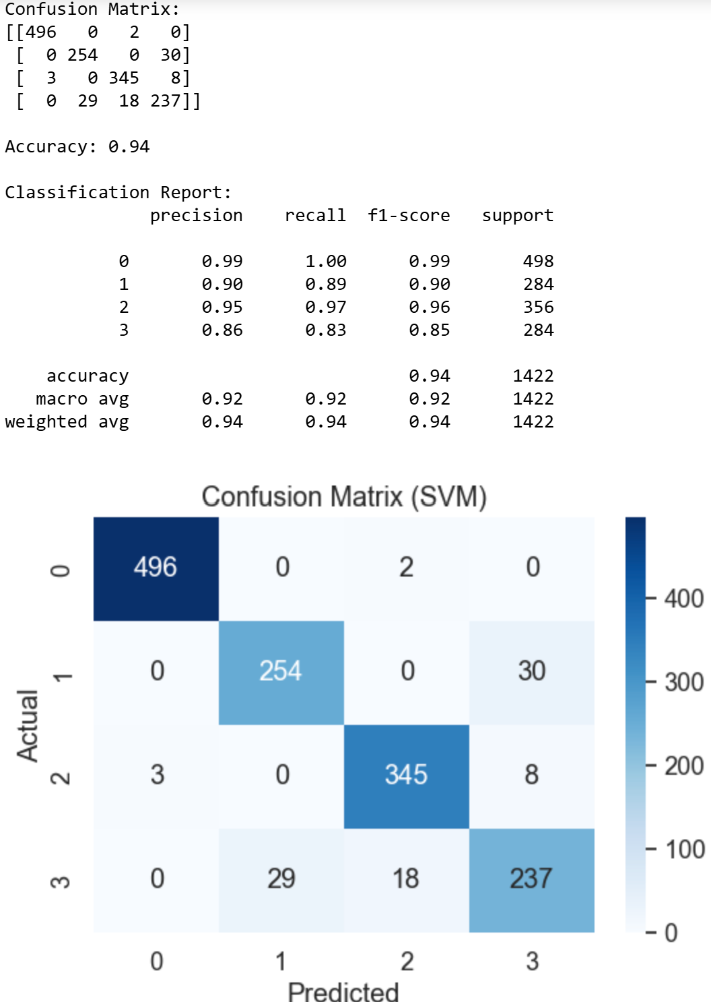

KNN
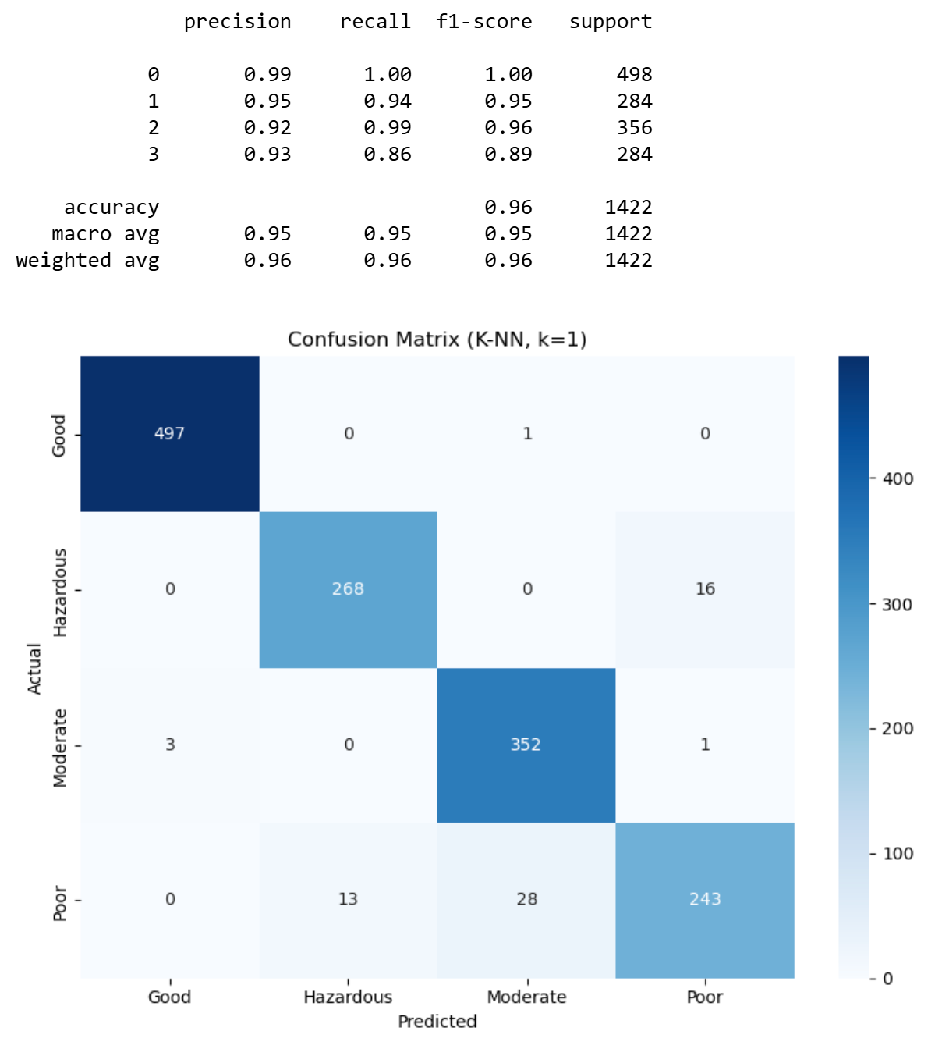

Conclusion
In Electrical Engineering, classification is really useful for solving real-world problems. For example, it can help detect unsafe air quality, spot faults in power systems, or analyze signals more effectively. Having a good classifier means we can make smarter and faster decisions based on data. This kind of tool is becoming more important in the field, and learning how to build and use it gives us an edge in tackling everyday engineering challenges.

